8 Way Horizontal Mounted Rackmount Non Switched IEC PDU - UK Sockets (PDU-8W-H-UK-IEC)

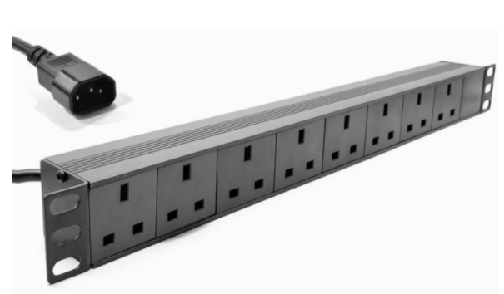

Description:
The LMS Power PDU-8W-H-UK-IEC is a high-quality 19-inch Rackmount PDU (Power Distribution Unit) that simply fits within the universal horizontal mounting brackets of data, telecom and server cabinets.
A must-have accessory for your data cabinets if you need to provide effective power to devices including Ethernet Switches, Servers, UPS, NAS and of course cabinet accessories including cooling fan trays.
Robust, alloy design complete with rackmount brackets fitted, UK output sockets together with a high quality, certified IEC-14 power input plug.

Key Features:
Standard UK 3-Pin power outlets for your appliances
Certified IEC-14 power input plug
1U high means the PDU can fit into the smallest cabinet
Backed up by LMS Power's exclusive 3-year warranty

Product Code:
Part Number: PDU-8W-H-UK-IEC
EAN: 8400800036094
Weight: 1.1Kg approx

Technical Specifications:
Warranty LMS Data 3-Year Warranty
Chassis 1U 19-inch with mounting brackets
Output Sockets 6 UK 3-PIN Sockets
Power Input Fitted IEC-14 Plug
Flex Length 1.8 metres (approx)
Power Rating 4000 Watts (approx)

Supplied With:
PDU-8W-H-UK-IEC 8 Way Horizontal PDU
19-inch cabinet brackets (Fitted)
* Specifications and product design are subject to change. E&OE.

Looking for highperformance power distribution for your heavily loaded systems? The newly developed LMS Data 13A heavy-duty horizontal PDU using the IEC-14 plug input connector which is ideal for many device requirements including server, network and other industrial-type equipment functions such as broadcast and HVAC applications. Combining a fully certified IEC-14 plug input combined with a compatible heavy load power flex means you can be assured this LMS Data PDU can work without problems, 24/7. Furthermore, incorporated onto the horizontal form-factor are industry standard UK sockets, ideal for data, telco and broadcast equipment with the added benefit of integral electrical surge protection. Robust in design, with an integral neon illuminated rocker switch for assured functionality, the LMS Data PDU is designed to deliver maximum electrical power today and tomorrow.

specifications:
Horizontal Power Distribution Unit (PDU)
Certified IEC-14 power input plug
Compatible, heavy-load power cable
6x UK power sockets
Robust, black aluminium design for industrial use
Neon on/off power switch for assured control
Maximum power rating - 4000W
2.0 metre (approx.) power cordage
Ideal for data, telecom, broadcast and HVAC applications

